**APPENDIX F: USER MANUAL**

**SMART UNIVERSITY SYSTEM**

**User manual**

**System Overview**

# This is a total solution for ICBT university. The main function of the system is to provide access to specific people in ICBT. Registration of students, lecturers and courses are should be done in order to further function of access controls in lecture rooms.

System Requirements

* Dual Core CPU at 3GHz
* 2 GB Memory (4GB for 64-bit operating system)
* Windows 7 32-bit operating system
* Java Run Time Environment 7
* Disk space : 1GB
* XAMPP server
* Apache Tomcat Server

**Installation Guide**

Please install required supporting softwares as mentioned below

**Step 1:**

Install Apache Tomcat Server

You can download freely at

<https://tomcat.apache.org/download-60.cgi>

**Step 2:**

Install XAMPP Server Console

You can download freely at

<https://www.apachefriends.org/download.html>

**Step 3:**

Install Java Runtime Environment

You can download freely at

<http://www.oracle.com/technetwork/java/javase/downloads/jre7-downloads-1880261.html>

**Step 4:**

Now you are ready to install Smart University System.

Double click the setup file and follow the instructions and install

Now open the Smart University System by double clicking the icon in your desktop

Enter the provided password and user name in the fields.

Smart University System

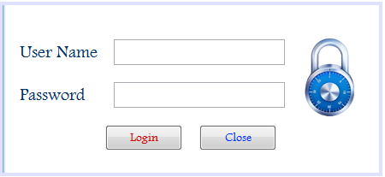

Enter your user name and password below

**After Successful login, you are directed to home page**

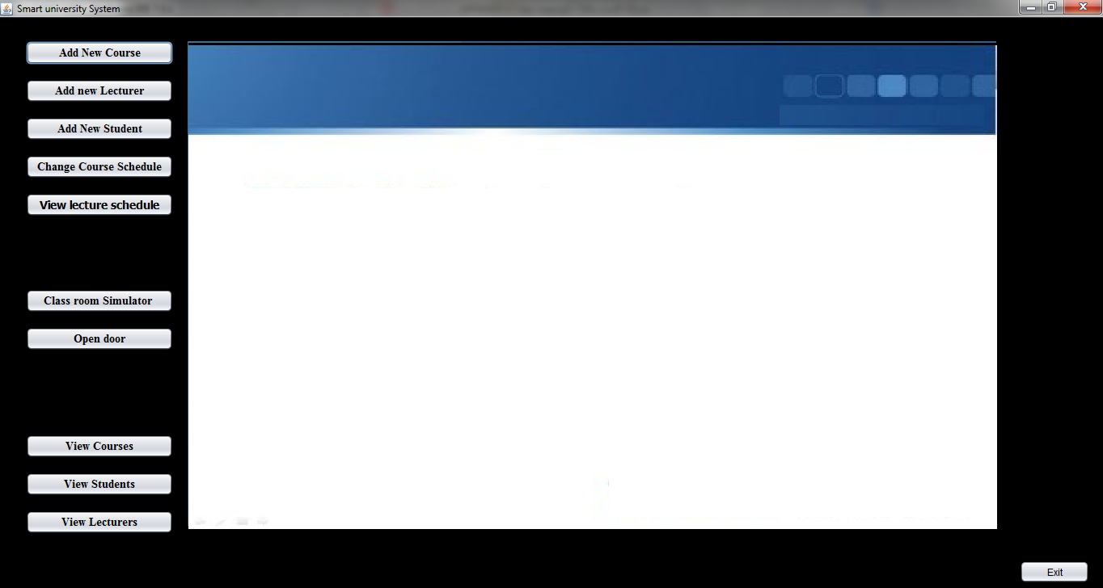

**Choose what you want to do**

**from left panel**

**Smart Unoversity System**

From the left menu click any button to access relevant functions

The list functions of the Smart university system. Following are the buttons available in left menu of the home page

**Add New Course**

1. In here you can add any new course to the database.
2. Fill in all the information regarding the course
3. Select the lab number under ‘Class room’. And then Select the schedule day for the course.
4. Now can submit the data to the database by clicking ‘Register’ button.

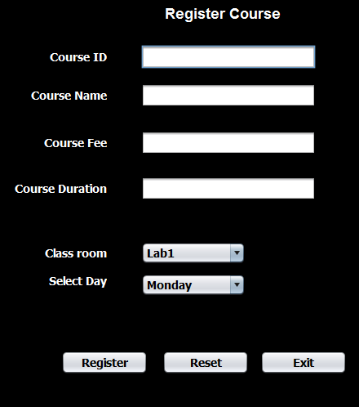

**Add New Lecturer**

1. In this window, you can add any lecturer to a specific course.
2. Fill in all the details. And tag a new RFID card to the reader, and then the RFID number will be filled in the ‘RFID number’ text box.
3. Choose the course which the lecture is willing to conduct.
4. Click Register to add the lecture to the database

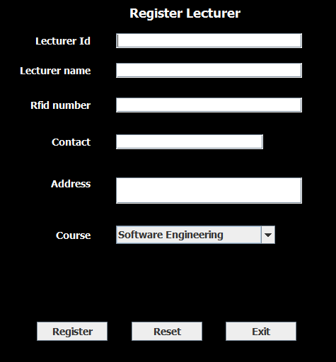

**Add New Student**

1. In this window you can register new student to the University
2. Fill all the details and tag a new RFID card to the reader, and the number will be automatically filled in the ‘RFID’ text box
3. Choose the course he/she willing to enroll, and enter the paid amount under the ‘Paid’ section
4. Now click ‘Register’ to add the student to the specific course

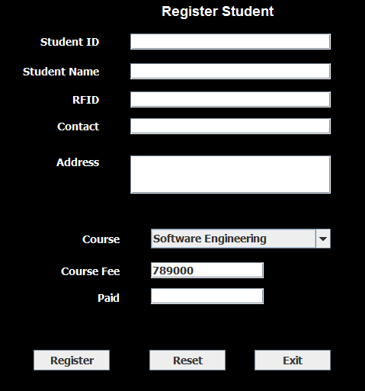

**Class room simulator**

1. So now the students and lecturers will have access to the lecture rooms allocated to them specifically. To check this with the class room simulator, click the ‘Class room simulator’ button. Then the simulator will open as shown below.
2. Here you can check whether the student or a lecturer has access to the specific lecture room.
3. Swipe the card to reader 1 and reader 2 to check the access of the specific RFID card.

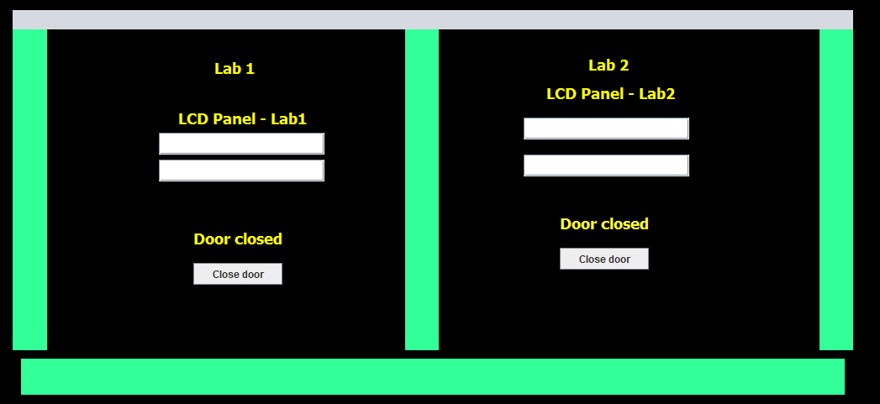

* If the students with payment arrears try to access the lecture room, he will not be allowed inside. And at the same time, he will revive a text message informing the payment arrear details.
* When a lecturer comes in the lecture room, a text message will be sent to all students of the specific course.

**Open door button**

You can check the door is working perfectly by this button, If you click this the door will be opened in the specific class room. This is to make sure if the door lock is working perfectly without errors

**Change lecture schedule**

1. In this window you can change any lecture schedule
2. You can choose any course under the lab number to which it has to be allocated.
3. Next choose the day of the lecture if it has to be changed
4. Then click ‘Reallocate Lab’ to change the course to the needed day and lab.

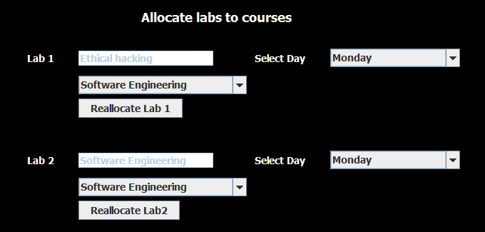

And when the lecture schedule is changes, a text message will be sent to all the students and lecturers in the specific schedule changed course.

The three buttons in the left bottom are for viewing all the records in the database.

1. View courses

In this window, you can view the entire registered courses in the university.

1. View students

You can view the entire registered student in this section

1. View lecturers

You are able to view the entire lecturers in the university under this section

Please do not hesitate to contact us for any further inquiries

M.G.Husny Ahamed

(+94 ) 77-65 11 996

mgha123@gmail.com